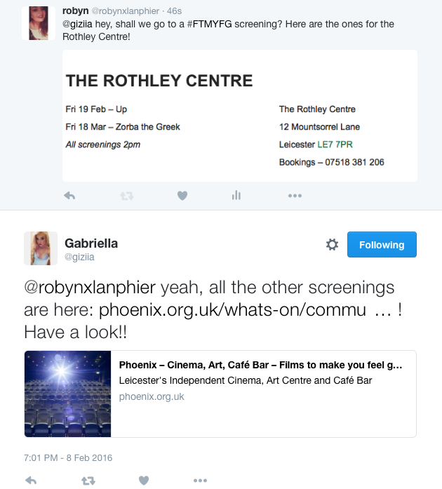

#FTMYFG

Films To Make You Feel Good is a project dedicated for those who are vulnerable or people who need company and even something little like a conversation. It allows people to sit down, enjoy a good film, have a cup of tea and perhaps talk to other people about the film or even have a general chit chat. We’ve spoke to people who to said that this project is a reason they want to leave the house and they can’t wait for a next screening. And this is why we do it.

🡪 Facebook allows you to create events, so you can invite people, and gather a better understanding of how many people will attend these events.

🡪 You can create a pages, with details of any upcoming events, with times and locations! This is a good way to interact with audiences.

🡪 Like Twitter, Facebook has a hashtag option now too. This works in the same way Twitter does.

🡪 Facebook, alternatively is very good to connect with friends and family around the world

🡪 You can share, like and upload videos and photos too!

An (Even Shorter) Guide on How to Use

* You don’t have to read every tweet... you can just skim through your timeline if you like.
* Some people barely tweet.
* Some tweet all the time.
* And some don’t tweet at all, they just use twitter to see other’s tweets.

A Short Guide on How to Use

* 140 characters per tweet.
* Your followers can see your tweets.
* Privacy options – you choose who follows you and who can see your tweets.
* You see tweets from the people you follow.

By Gabriela Ferenc & Robyn Lanphier

The three dots just extends the tweet so you can see the date and time it was posted, and any other user interactions with this tweet.

🡪 Liking another person’s tweet shows your appreciation for it.

🡪 It then saves into your likes, and you can see your likes anytime you like on your profile.

🡪 To retweet another users tweet, click the button with two arrows.

🡪 You can “Quote Retweet”, which means you add your own comment onto the tweet.

🡪 Or, you can simply retweet to share this tweet on your own profile.

How to….

Like

a tweet!

a tweet!

Retweet

🡪 To reply to another users tweet, simply click the arrow button underneath their tweet.

🡪 Clicking on this button will pre-make a tweet for you with their @handle ready so you just need to write your reply and send!

to a tweet!

Reply

How to….

How to….

Mention

How to….

another user!

🡪 To mention someone, use the @ sign before their username (with no space)

🡪 They will then receive a notification from your account to theirs.

🡪 You will also receive a notification if they **reply**, **retweet** or **like** your tweet.

A hashtag (#) on twitter becomes a link. If you click on the link of a hashtag, each tweet that also has mentioned the hashtag will come up, so you can see other tweets shared about the same topic.

When a hashtag is used all over the world a lot, it becomes “Trending”. This means it becomes a popular topic being tweeted about, and people can input their opinions, or see others opinions or more information on the topic or event – then creating a live discussion on an event.

🡪 To add a weblink, simply copy and paste the link into your tweet and twitter will shorten the link for you.

🡪 To add a photo or video to your tweet, click “Media” and select what you want to post.

to your tweets!

Add Weblinks and Photos

How to….